**TasTAFE RESIDENCE** Instructions for Alanvale Key Box

**Below is a map showing how to access TasTAFE.  Outside of business hours you need to access the residence via Tompsons lane.**

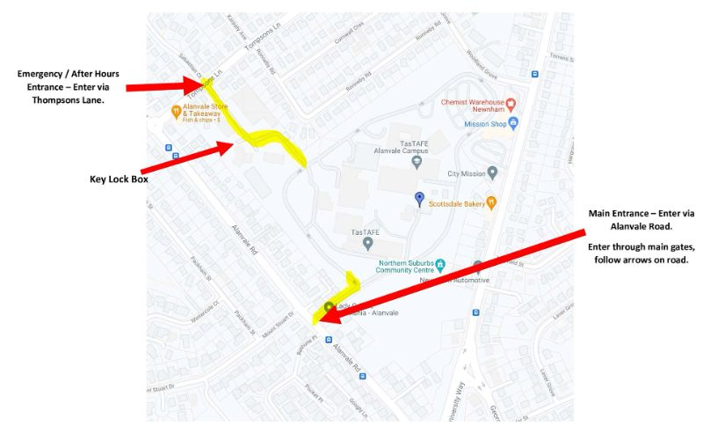

**The lockbox is located down the driveway to the right of entrance door to Residence 2 – ‘ N ‘ block (closest to Tompsons Lane).**

**Between the two garage doors .**



